Name __________________________________________ Date ____________ Per _______
Observation & Inference
- Which literary character is well known for their exceptional observation and inference capabilities?
2) In the space below differentiate between observation and inference by filling out the definitions of each
Observation:
Inference:
3) As we watch this video write down 5 observations that he makes. When we watch it again try and catch 5 inferences he makes based on those observations.
Observations |  |  |  |  |  |  |  |  |  |  |  |  |  |  |  |  |  | Inferences

4) Now that we’ve established the differences between observation and inference and watched the master at work, let's discuss how observation and inference relate to our biology class and science in general. First, let's talk about what we use to make observations of the world around us. In the space below, write in what you think that we use to make observations (at least 3)
- 2. 3.
5) Take a minute to think about some of the scientific discoveries of the past and present. Were those discoveries made using nothing but what was listed above, probably not. In the space below list some instruments scientists use to investigate and make discoveries. (at least 3)
- 2. 3.
6) Before we move on, we need to start applying some academic terminology to the concepts we’ve been discussing. When scientists use their senses and instruments to make observations, the information that is collected from those observations is known as what?
7) There are two categories that measurements fall under, can you list the two categories of measurement below?
8) Now that we have most of the pieces, let’s read a couple quick excerpts tying things together
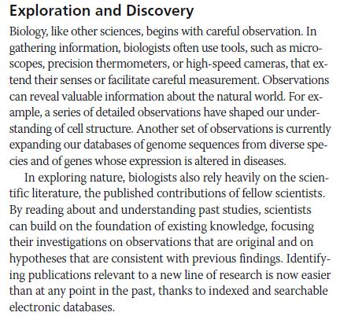 | 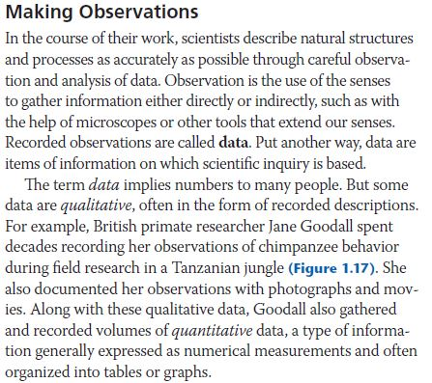
9) After reading the excerpt above answer the following questions in the space below each question | 10) After reading the excerpt above answer the following questions in the space below each question
- The scientific process begins with?  - Instruments like microscopes & cameras can be used to do what in science?  - On top of the observations that scientists collect on their own, what else do scientists rely on to further their research? | - Recorded observations are called?  - How is data related to scientific inquiry?  - Describe what qualitative data is.  - Describe what quantitative data is.
11) Let’s apply our new understanding of data collection to some scientific instruments. Below there are two columns. Think of two instruments (1 for each column) and briefly describe a type of data it can be used to collect (see example in each column). Keep in mind, some instruments might be able to collect data from both columns
Quantitative Data | Qualitative Data
- Microscope (example)  - Can be used to count the number of blood cells in a sample | - Microscope (example)  - Can be used observe the steps in cell division

12) Let’s look back at our Sherlock Holmes clips, apply some of our new academic terms and introduce some new ones. Most of Sherlock’s observations were of what type (qualitative or quantitative)? Briefly explain your answer
13) The scene snips below are from the second Sherlock video you watched. Let’s examine what happened in these scenes and make connections to how his thought process relates to scientific methods.
Part 1 | Part 2
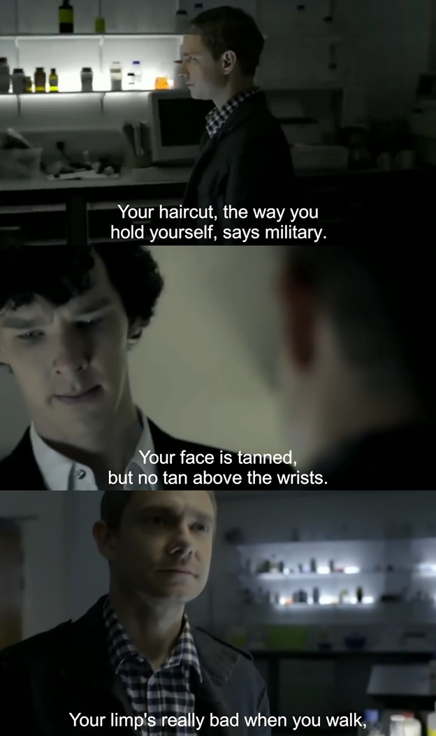 | 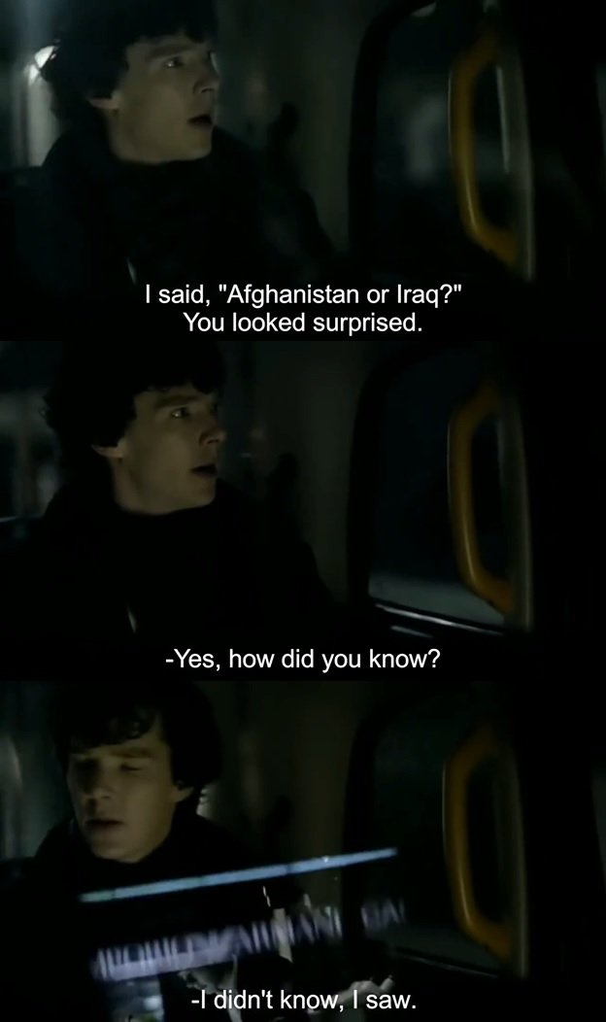
14) Let’s do a quick analysis of the differences between Part 1 and Part 2. Fill out the table below
What were the specific observations (at least 3) made by Sherlock in the above scene (part 1) | What was a general claim made by Sherlock in the above scene (part 2)
15) Just like there are different types of data in science (qualitative and quantitative), there are also different types of reasoning in science. One type of reasoning flows from the direction of general premises to the extrapolation of specific results, the other type of reasoning flows from the direction of specific observations to a general conclusion. Read the scenario below and two excerpts underneath it to understand how the two types of reasoning relate to observations and the scientific method.
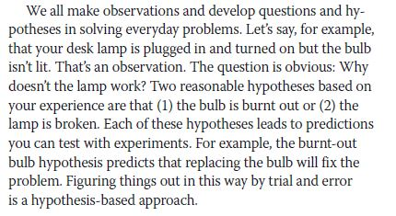
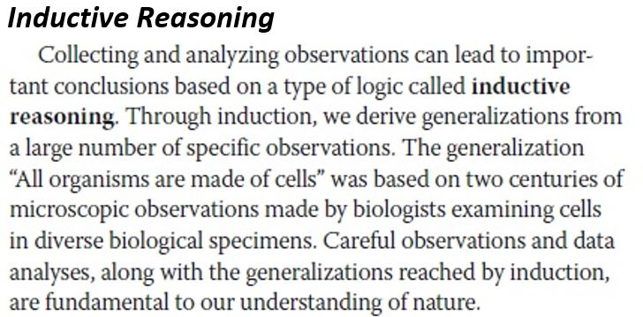 | 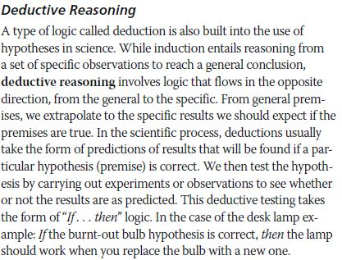
16) Sherlock has a nickname, he is known as the “Master of Deduction.” Based on the video clip we watched, our understanding of scientific reasoning and the diagram below, do you agree that Sherlock Holmes is a “Master of Deduction”? Why or why not?
